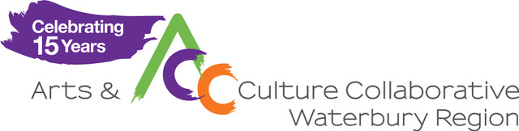
Arts & Economic Prosperity Coordinator
The Arts & Culture Collaborative (ACC), Waterbury Region, is seeking an independent contractor to oversee our region’s participation in Arts & Economic Prosperity 6, a national study on the economic impact of the arts from Americans for the Arts.
Arts & Economic Prosperity 6 (AEP6) is a study of the nonprofit arts and culture industry in the U.S. The study’s purpose is to gauge the economic impact (jobs, government revenue, household income) of spending by nonprofit arts and culture organizations and the event-related spending by their audiences.
The Arts & Culture Collaborative is looking for an outgoing, organized, self-starter to lead the study in our region. Responsibilities will involve working directly with arts organizations to coordinate data collection, as well as recruiting, training, and coordinating volunteers to collect surveys at arts events across 14 towns in our greater Waterbury area and Naugatuck Valley service area. Managing data and producing quarterly reports will also be required.
Job responsibilities
- Work with the ACC Administrator and community partners to recruit volunteer survey collectors
- Train volunteers in effective survey collecting techniques and coordinate survey collection at arts events across the Greater Waterbury Region and Naugatuck Valley
- Prepare completed surveys for analysis and submission to national study, including quarterly reports
- Manage AEP6 timelines for data collection and analysis
- Attend virtual meetings with statewide and regional partners
Qualifications and skills
- Experience and interest in data collection and analysis
- Volunteer management experience
- Training or facilitation experience
- Ability to work under pressure and manage multiple projects and priorities at the same time
- Proficiency in the Microsoft Office Suite, particularly Excel, required
- Self-starter, decision maker and problem solver
- Enjoy networking and community building
(continued. . . )

About the Arts & Culture Collaborative
Established in 2006 under the auspices of the Greater Waterbury Chamber of Commerce Foundation, the ACC’s mission is to strengthen and support the arts in the Waterbury region and Naugatuck Valley as a central component of furthering economic development and enhancing the quality of life for area residents. The ACC serves as a go-to resource for arts and culture. The ACC continues to grow and evolve as it promotes, connects, collaborates, and advocates for the arts. Member-based, the ACC serves individual artists and performers, arts and cultural venues and organizations of all sizes as well as their audiences.
Details of this position:
- Independent contractor position from mid- June 2022 through May 2023
- Estimating an average of 5 hours per week
- $18 - $20/hour, depending on experience
- Hybrid work environment. Attendance at local arts events required
- Evening and weekend availability may be required

To apply, interested candidates should submit a cover letter and resume to dploch@waterburyregionnarts.com and reference “AEP6 Coordinator” in the subject line.

