#ArtisPartCT Toolkit

Thank you for downloading CAA’s ArtisPartCT Toolkit! Here, you will find all you need for you or your organization to engage with the campaign and spread the simple message – Connecticut Can’t Recover Without the Arts!

Contents:
- Graphics
  - Hashtags and other resources
- 2021 Legislative Agenda
- State Statistics and Facts
- COVID-19 Impact Data
- Talking Points

Graphics
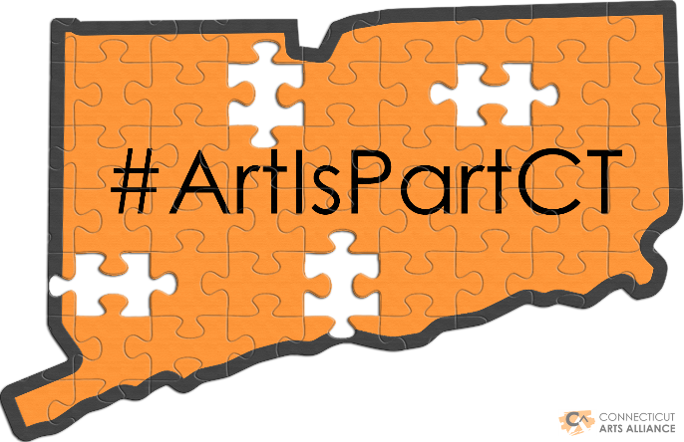
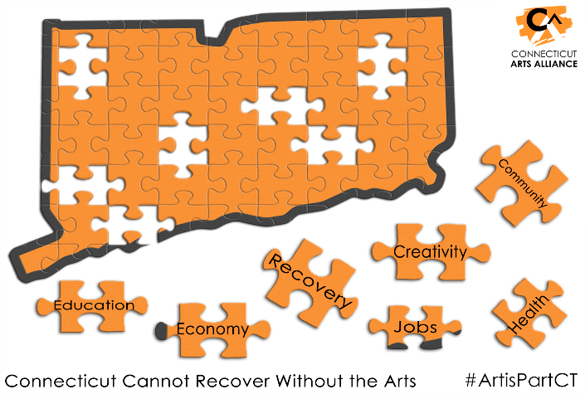

Image Sizing Guide for Social Media
Facebook: 1,200 x 630 pixels (px)
Instagram: Square – 1080 x1080px | Landscape – 1200 x 630px
Twitter: 1,200 x 630px

Hashtags and Other Resources
#ArtisPartCT
Slogan – Connecticut Can’t Recover Without the Arts
** Use the hashtag in posts for an opportunity to be reshared on CAA social media channels
Twitter - @ct_artsalliance
Facebook - @ctartsalliance
Website - https://ctartsalliance.org/
Campaign Homepage - https://ctartsalliance.org/art-is-part-ct/

2021 Legislative Agenda
ARTS AND CULTURE SECTOR IS AN ECONOMIC DRIVER
Represents 5% of CT’s economy | Generates $9 billion annually | Supports 57,000 nonprofit jobs
Returns $7 for every state $1 invested¹

COVID-19 HAS DEVASTATED THE SECTOR

CT CAN’T RECOVER WITHOUT THE ARTS
Empty Downtowns | Venues Closed | Economic & Job Loss |Permanent Closure & Damage
LEGISLATIVE ACTION IS REQUIRED
Prevent further economic injury and job losses | Address the impact of shutdown and accumulated losses |
Help Accelerate Recovery, not only for the sector but for all of Connecticut

The Tourism Fund is CT’s mechanism to fund arts, culture and tourism. The fund’s revenue source is the Hotel Occupancy Tax, which has underperformed as a result of the pandemic’s impact on the hospitality industry. According to the Office of Policy and Management (November 2020) “the Tourism Fund will end FY 2021 with a $13.8 million negative fund balance.”

Citations:
¹ U.S Bureau of Economic Analysis CT State Report and Arts & Economic Prosperity 5 for State of CT
² U.S. Bureau of Economic Analysis CT State Report
³ Lost Art: Measuring COVID-19’s devastating impact on America’s creative economy (Aug. 2020, Metropolitan Policy Program at Brookings)
⁴ COVID-19’s Impact on the Arts Research and Tracking Update: Americans for the Arts

2021 Legislative Agenda

PRIORITY: REPLENISH THE TOURISM FUND to prevent further economic injury and job losses in the sector and maintain flat funding. GROW THE TOURISM FUND to help stabilize sector and accelerate recovery
- DEDICATE 25% OF PROCEEDS FROM LODGING TAX TO TOURISM FUND by increasing the allocation from 10% to 25%. The increase does not affect lodging tax rates.

- ALLOCATE A PORTION OF PROCEEDS FROM OTHER STATE TAXES AND/OR NEW REVENUE.

PRIORITY: ENSURE FUNDING FOR CT OFFICE OF THE ARTS AND CT HUMANITIES reflects their roles as the state’s main source of support for arts and culture nonprofits in every municipality.
PRIORITY: ENSURE THAT ARTS AND CULTURAL NONPROFITS ARE SUPPORTED BY ADDITIONAL FEDERAL FUNDING TO CT with a focus on grants for operating support as opposed to loans.

Federal Legislators | State Legislators & Administration | CT Arts Alliance
Continue to ensure dedicated federal funding to arts & cultural organizations survival and workers’ jobs. | Address accumulated losses, prevent further economic injury and permanent job and institutional loss. | Establish a statewide advocacy network of arts advocacy teams to call on and engage in advocacy efforts.

State Statistics and Facts

State Investment in Arts & Culture

- Total Appropriation | $5,499,552
CT Per Capita | $1.54
RI Per Capita | $2.16
MA Per Capita | $2.03

20% decrease since 2011

In the State Budget, “Arts Commission” = State Arts Agency = CT Office of the Arts

- Arts and cultural nonprofits are funded through CT Office of the Arts and individual line items

- $1.5M to “Arts Commission” and $2.7M to line items for individual arts organizations

$1 for Tourism is NOT $1 for Arts & Culture

- The arts are distinct from but a cornerstone to tourism

- Office of the Arts, housed in DECD, funds its operations and grants to nonprofit arts and cultural organizations throughout Connecticut

- Office of Tourism, also housed in DECD, funds its operations and statewide marketing

Return on Investment

- CT’s arts investment of $4.2M generates
$1 to Arts = $7 to State Govt *
$42M in revenue to state government

- CT’s nonprofit arts & culture industry
generates $800 million in total economic activity

- MA and RI have followed national trend and increased investment in the arts in recent years

*Source: Arts & Economic Prosperity 5 by Americans for the Arts

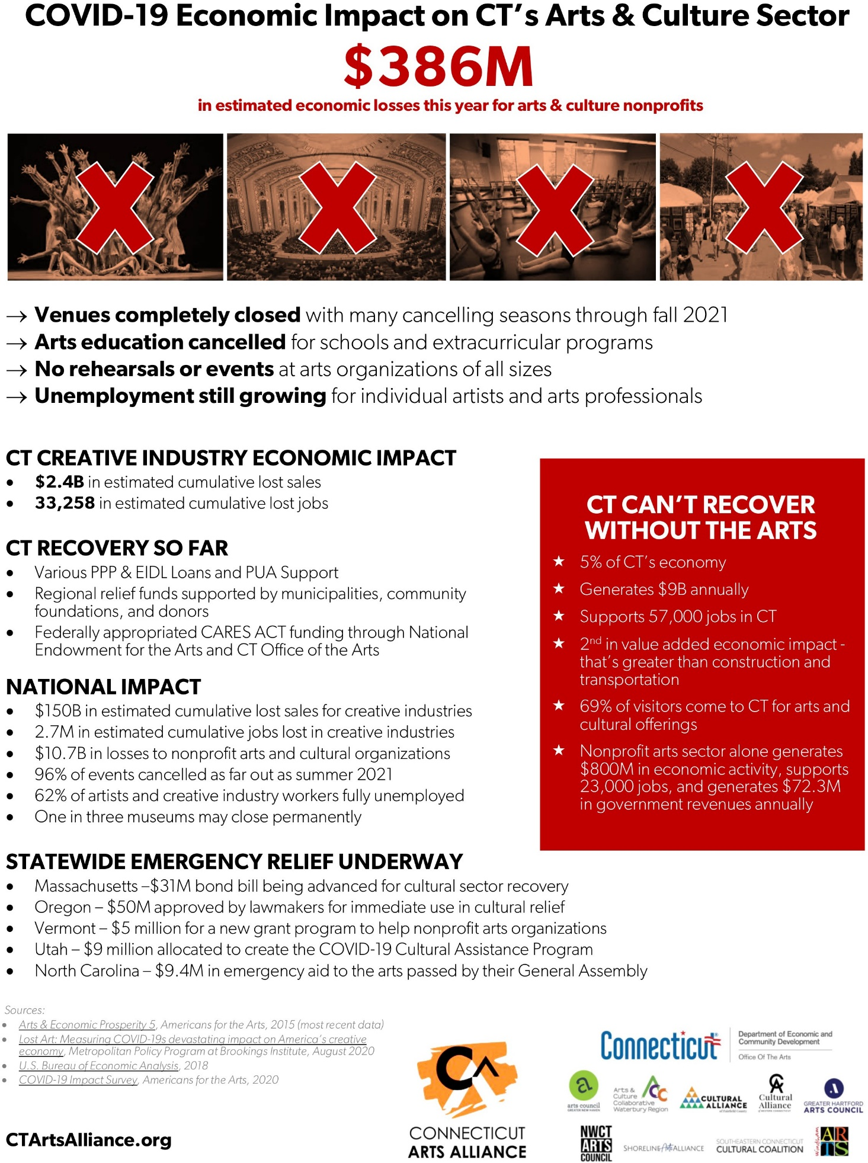
COVID-19 Impact Data

Talking Points
The Arts Sector
- 5% of the state's economy
- Generates $9 billion annually
- Supports 57,000 nonprofit jobs
- Is 42nd nationally in state funding (excluding line items for specific organizations and groups)
COVID-19 Impact
- Lost $2.4 billion in sales
- Lost 33,258 creative economy jobs
- Lost $400 million in revenue for arts and cultural nonprofits
We Ask Legislators To:

- Replenish the Tourism Fund – The Office of Policy Management estimates that the Tourism Fund will end FY21 with a $13.8 million shortfall.
- Dedicate 25% of proceeds from lodging tax to tourism fund by increasing the allocation from 10% to 25%. The increase does not affect lodging tax rates.
- Allocate a portion of proceeds from other state taxes and/or new revenue.
- Ensure funding for CT Office of the Arts and CT Humanities reflects their role as the state’s main source of support for arts and culture nonprofits in every municipality

