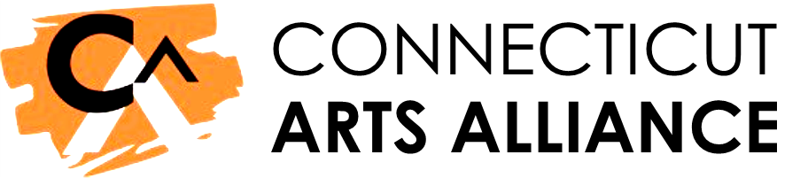
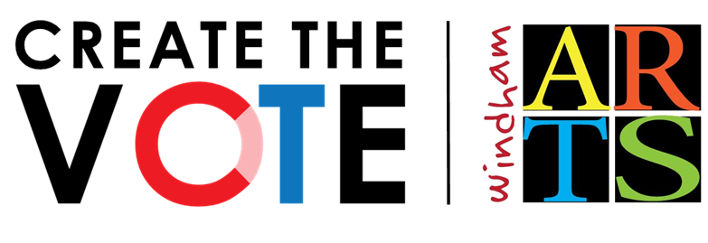
- Candidate Questionnaire
1. YOUR PERSONAL CONNECTION TO THE ARTS
The pandemic has been challenging for so many in CT and in so many ways.
How have you personally benefitted from the arts or creative expression in the last few months? What local arts experiences have you missed most during the shutdown?
2. ARTS + ECONOMIC RECOVERY
CT can’t recover without the arts. Arts and culture are key for CT’s economic recovery. Creative industries pump $9 billion into the state and account for 3.5% of CT’s total economy. Our non-profit arts organizations support 23,000 jobs, generate $800 million annually, and return $7 back in tax revenue for every $1 invested by the state.
How will you help harness the power of the arts for CT’s economic recovery?
3. ARTS HEAL + REBUILD
Creativity helps us process loss, fight loneliness, and create vibrant, resilient communities that attract and retain residents, businesses, and visitors.
What do you think is an important role for arts and culture to play in healing and rebuilding the social fabric of our cities and towns?
4. ARTS SUPPORT RACIAL & SOCIAL JUSTICE
The pandemic has deepened existing divides in Connecticut, particularly along the lines of race and class. The arts create shared experiences that can unite people and bridge divides to acknowledge the strength in our differences.
Do you believe the arts can help build racial and social justice in Connecticut? If so, how?
5. CT NEEDS HELP FROM THE ARTS
With 62% of artists unemployed and most arts organizations unable to reopen, the industry needs emergency support to recover and thrive. CT’s arts and culture sector has suffered an estimated $400 million in economic losses.
Will you support emergency funding to support the arts industry in Connecticut? If so, from what source and at what level?

